SES – Simple Email Service

Objectives
After completing this lab, you will know how to:
- Navigate the Amazon SES Dashboard in the AWS Management Console
- Verify an email address identity in Amazon SES
- Confirm the email verification from the inbox
- Send a test email using the SES Send Test Email feature
- Verify email delivery in the recipient inbox
- View email sending statistics and reputation metrics
- Understand the difference between Sandbox and Production mode

Step 1: SES Dashboard
The Amazon SES Dashboard is the starting point for managing email identities, configurations, and sending activity.
- Log in to your AWS Management Console using your root or IAM user account.
- In the top search bar, type SES and select Amazon Simple Email Service from the results.
- The SES Dashboard opens, displaying Account overview, Identities, Configuration sets, and Suppression list.
- The dashboard also shows your current sending limits, reputation metrics, and account status.
- By default, new accounts are placed in the SES Sandbox — meaning only verified emails can be used.

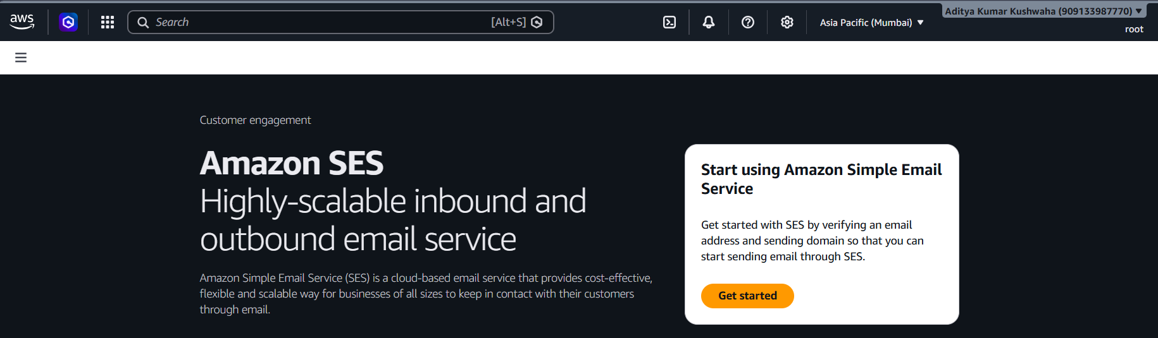

Step 2: Navigating to Email Identities
An Identity in SES is an email address or domain that you verify to use as a sender.
- In the left navigation panel, click on Verified identities.
- The Verified Identities page shows all email addresses and domains that have been verified.
- A verified identity is required before you can send emails through SES.
- Click the Create identity button to begin verifying a new email address.

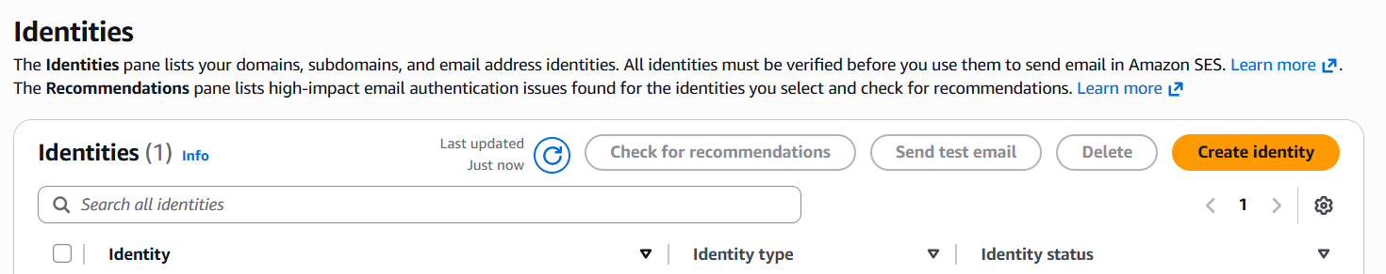

Step 3: Creating an Email Identity
In this step, an email address is submitted for verification to use as the sender in SES.
- Under Identity type, select Email address.
- In the Email address field, enter: adityakumarkushwaha021@gmail.com
- Leave all other settings as default.
- Click Create identity.
- SES will immediately send a verification email to the entered address.
- The identity status will show as Unverified until the email is confirmed.

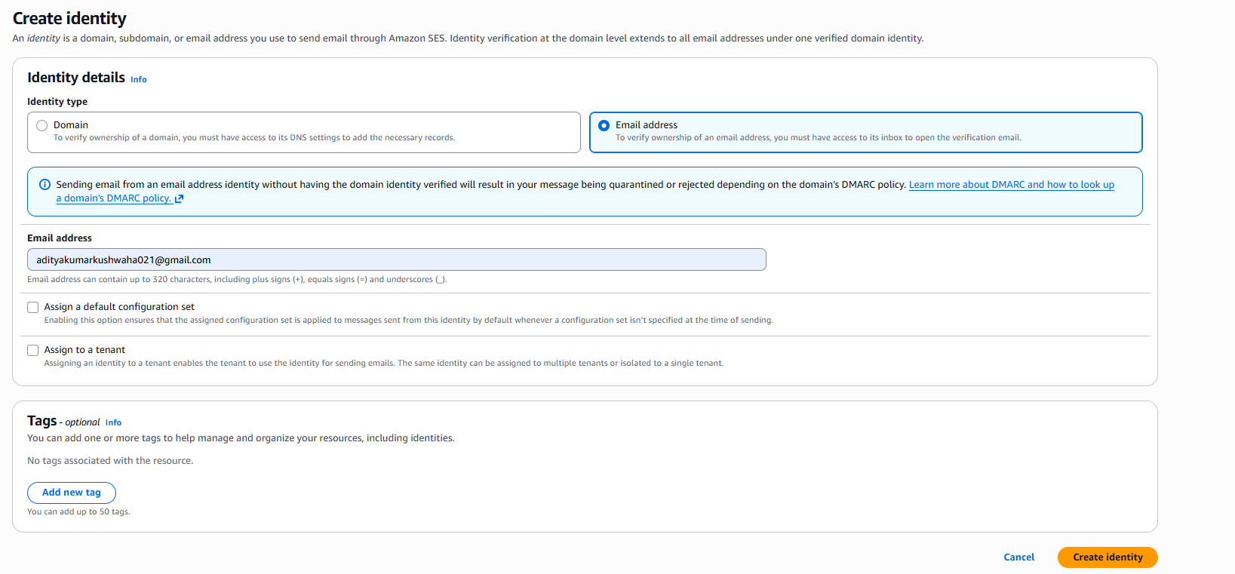

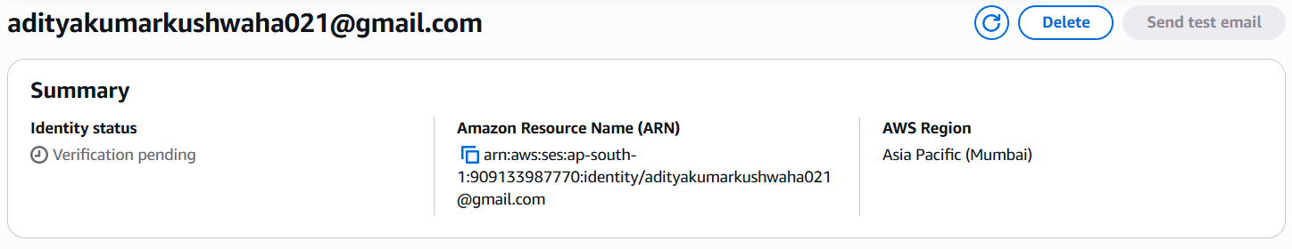

Step 4: Confirming the Email Verification
AWS sends a verification email — it must be confirmed before the identity can be used to send emails.
- Open the inbox of adityakumarkushwaha021@gmail.com in your email client.
- Look for an email from AWS with subject: "Amazon Web Services – Email Address Verification Request".
- Open the email and click the verification link inside.
- A browser page opens confirming: Congratulations! Your email address has been successfully verified.
- Go back to the SES Verified Identities page and refresh.
- The identity status will now show as Verified with a green checkmark.

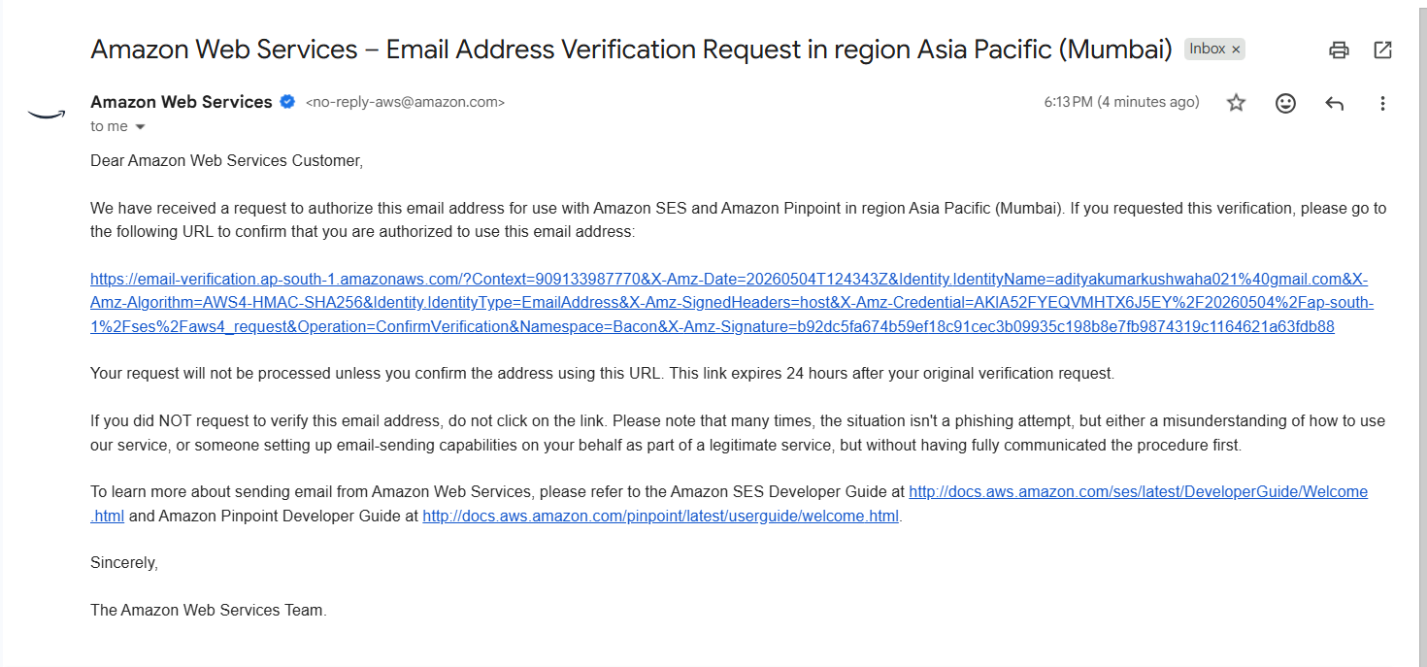

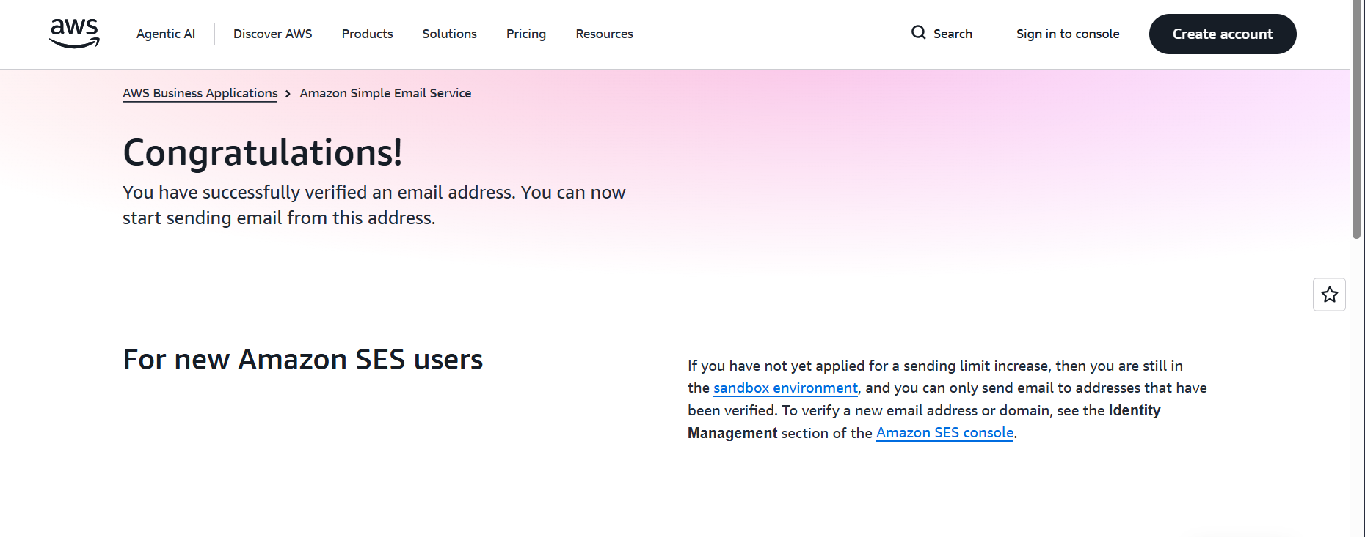

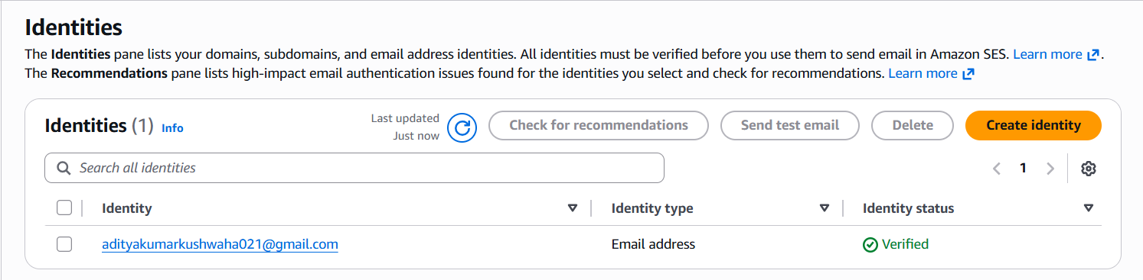

Step 5: Verifying the Recipient Email Address (Sandbox Mode)
In Sandbox mode, the recipient email address must also be verified before receiving test emails.
- Click Create identity again on the Verified Identities page.
- Under Identity type, select Email address.
- Enter the recipient email address: adityakumarkushwaha012@gmail.com
- Click Create identity.
- Open the inbox of adityakumarkushwaha012@gmail.com and click the verification link in the AWS email.
- Both sender and recipient are now verified — you are ready to send a test email.

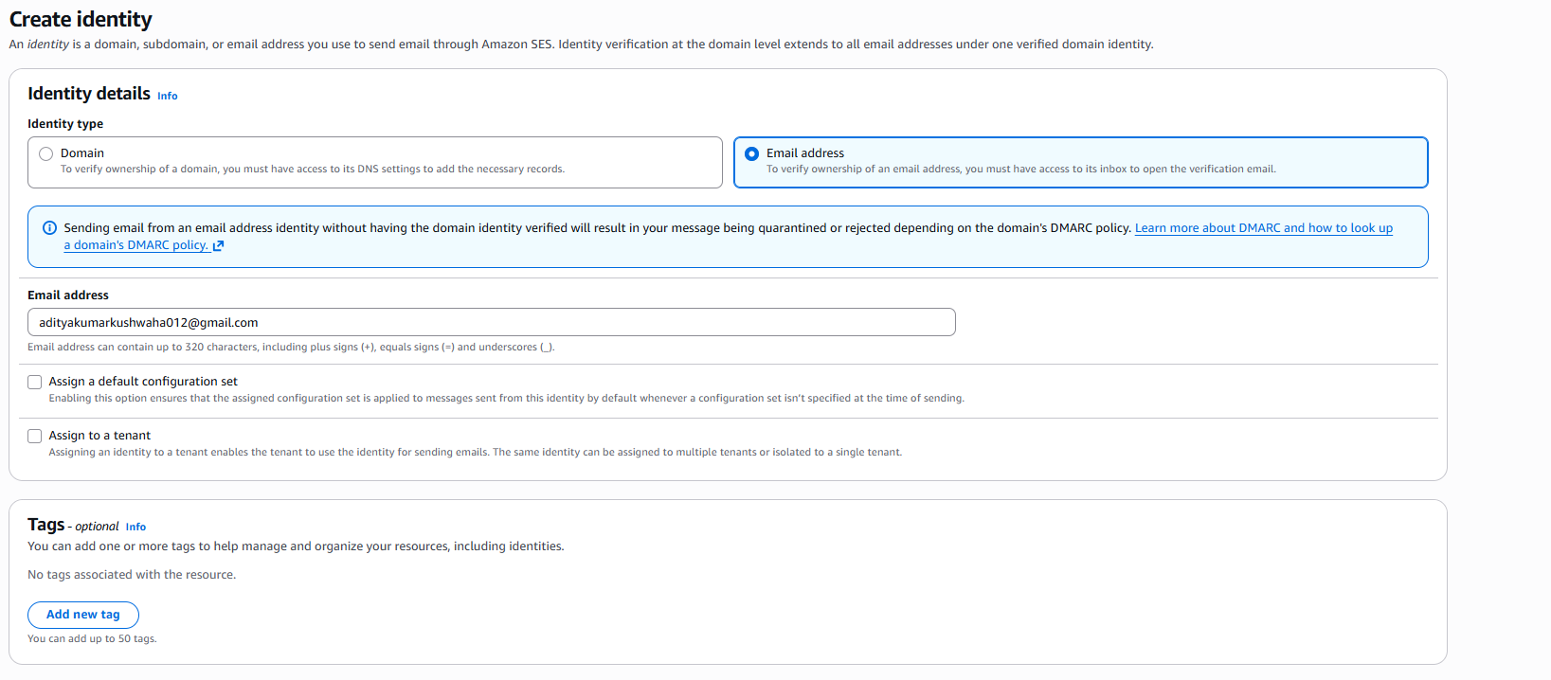

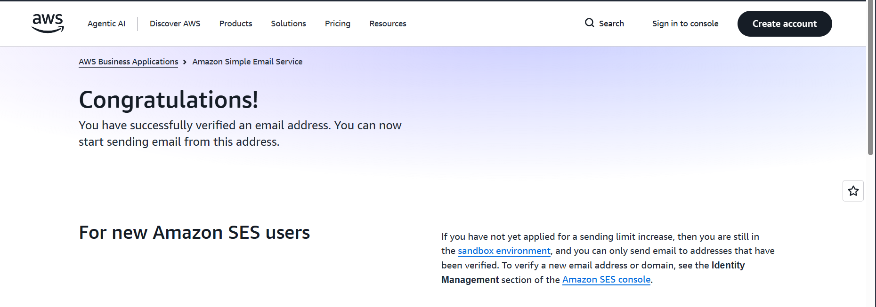

Step 6: Sending a Test Email
SES provides a built-in Send Test Email feature to verify that email delivery is working correctly.
- On the Verified Identities page, click on adityakumarkushwaha021@.com to open its detail page.
- Click the Send test email button at the top right.
- Under From address, your verified email is pre-filled.
- Under Scenario, select Custom.
- In the To field, enter: adityakumarkushwaha012@gmail.com
- In the Subject field, enter: Test Email from Amazon SES
- In the Body field, enter: Hello! This is a test email sent using Amazon SES by Aditya Kumar Kushwaha.
- Click Send test email.
- A success banner confirms the email has been sent.

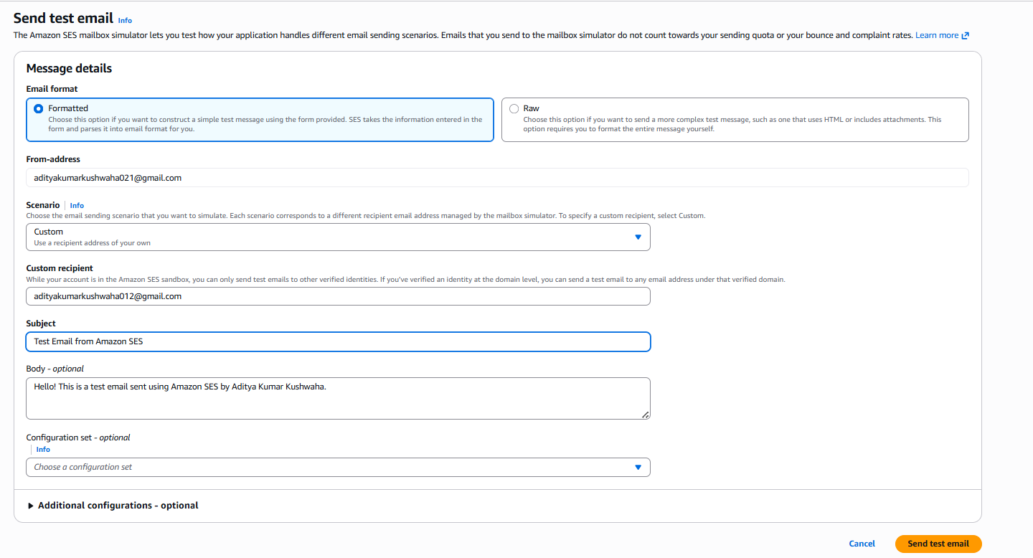

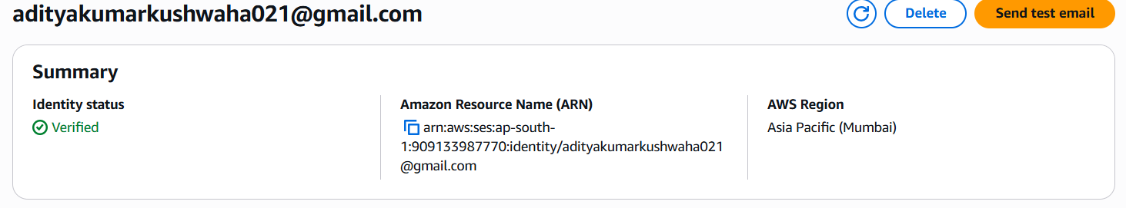

Step 7: Verifying Email Delivery in Inbox
Check the recipient inbox to confirm that the SES test email was delivered successfully.
- Open the inbox of adityakumarkushwaha012@gmail.com in your email client.
- A new email arrives with subject: "Test Email from Amazon SES".
- Open the email — the body should contain the message you entered in the previous step.
- The sender address will appear as your verified email address.
- This confirms that Amazon SES successfully sent and delivered the email.

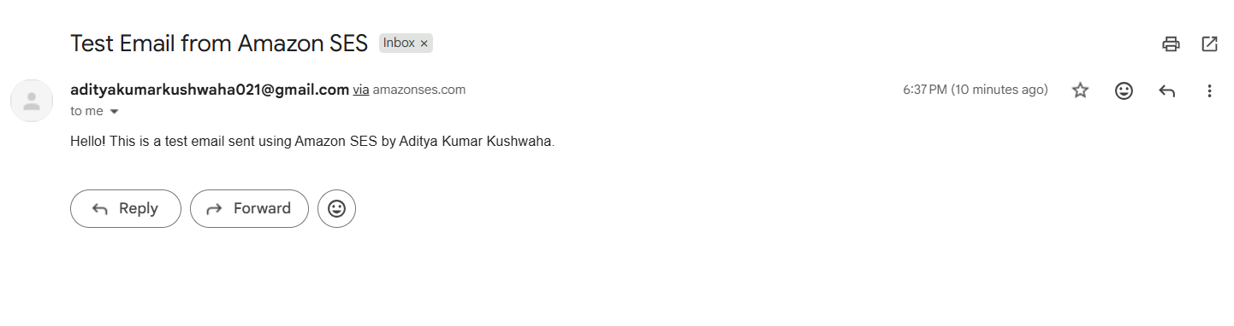

Step 8: Viewing Sending Statistics and Reputation
SES provides detailed metrics to monitor email delivery performance and sender reputation.
- In the left navigation panel, click on Account dashboard.
- The dashboard shows key metrics: Sends, Deliveries, Bounces, Complaints, and Rejects.
- Bounce rate should be kept below 5% — high bounce rates can cause account suspension.
- Complaint rate should be below 0.1% — recipients marking emails as spam affects reputation.
- Scroll down to view the Sending statistics graph for the past 14 days.
- Monitor these metrics regularly to maintain good sender reputation.

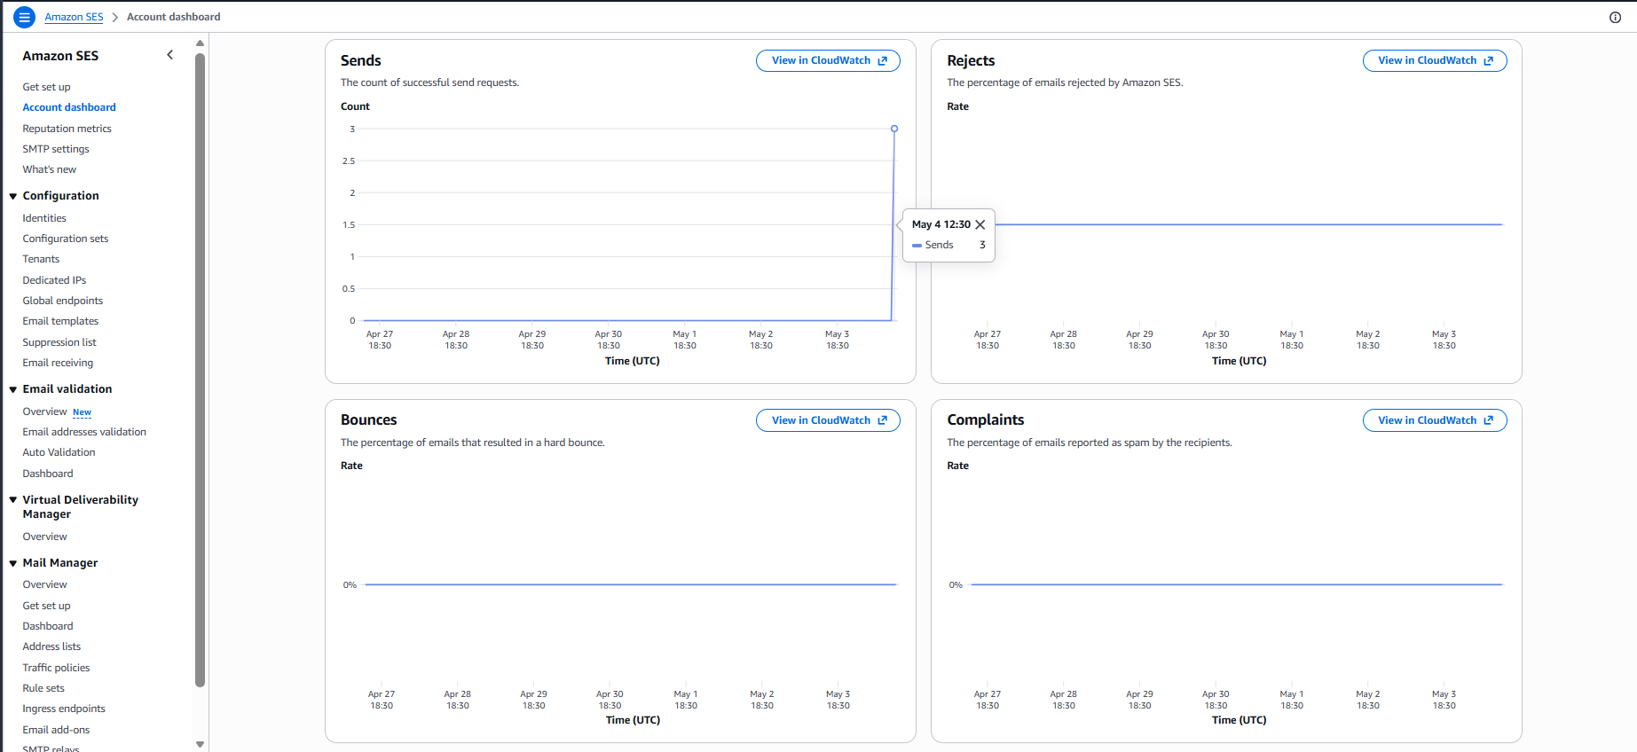

Step9: Deleting the Identity After Use
After completing the lab, the verified identities can be removed to keep the account clean.
- In the left navigation panel, click on Verified identities.
- Select the identity: adityakumarkushwaha021@gmail.com
- Click Delete and confirm the deletion.
- Repeat the same steps to delete the recipient identity: adityakumarkushwaha012@gmail.com
- Both identities are now removed from your SES account.

